Title: Exploring Push and Pull Migration Factors: Using Online Mapping Techniques and Primary Sources

Overview ⎸ Preparation ⎸ Lesson Procedure ⎸ Evaluation

Overview

Lesson Overview | Over three days students will work together in teams to examine historical maps, photographs, and documents. Students explore push and pull factors and how they affect migration patterns. This lesson provides a great introduction for students to use modern technology to analyze primary sources.  The online forms provide opportunity for student-centered inquiry into primary sources. They can be used to prepare students for Document Based Questions and may serve as preparation for the PARCC test.  The mapping project provides students the opportunity to evaluate mapping information and to create their own maps. It can be worked on by groups after they complete the learning module (Google Form) for the first 3 days. Day four can be used to allow students to finish their maps and then to present them. Between the online modules, where students have opportunities to study maps, and the mapping project, where students actually create their own, this lesson has students working at all levels of Bloom’s Taxonomy in understanding maps.
Author(s) | Eitan Fire
Grade Level/  Course | Middle School, High School, geography, history, language arts
Standards | Integration of Knowledge and Ideas:  CCSS.ELA-LITERACY.RH.6-8.7  Integrate visual information (e.g., in charts, graphs, photographs, videos, or maps) with other information in print and digital texts.  Key Ideas and Details:  CCSS.ELA-LITERACY.RH.6-8.1  Cite specific textual evidence to support analysis of primary and secondary sources.  CCSS.ELA-LITERACY.RH.6-8.2  Determine the central ideas or information of a primary or secondary source; provide an accurate summary of the source distinct from prior knowledge or opinions.  Craft and Structure:  CCSS.ELA-LITERACY.RH.6-8.4  Determine the meaning of words and phrases as they are used in a text, including vocabulary specific to domains related to history/social studies.
Time Required | Multi-Day, 3 to 5 50-minute class periods (depending on how much you draw out the mapping project).
Topics | Immigration, Mexico/Mexicans, New Mexico/New Mexicans  Outline topic: Early Hispanic migration to Boulder County
Time Period | 1900s-1910s, 1920s-1930s
Tags (keywords) | push, pull, maps, Middle School, High School, geography, history, language arts, Boulder, Longmont, social justice, demographic change, demography, immigration, Mexico, New Mexico, southern Colorado, mapping.

Preparation (Links to worksheets, primary sources and other materials):

Materials | Students will complete the online learning modules and the mapping project with the use of an internet connected electronic device. 3-5 students per device is suggested.
Resources/Links | The online learning modules should take students about 15 to 30 minutes. After all groups have completed the day’s module, discuss the answers with the whole class.  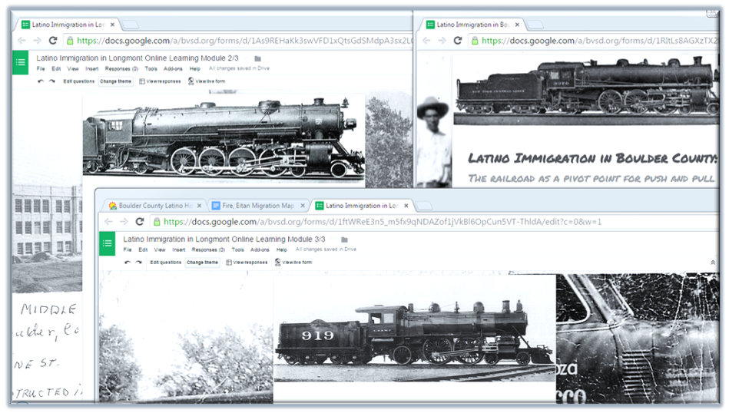  The links to the online learning modules below show you what the forms look like. Follow the directions below to see how your students answer the questions, customize the questions, and make it your own.  - For each “Teacher Copy” click on “File” and then “Make a Copy” to be able to have access to the spreadsheet with student answers and to customize the forms if you need to.  - Click on “Send Form” and you will see the URL (link) you need to copy to share with students or post online.  Online Learning Module 1 / 3  Teacher Copy  https://docs.google.com/forms/d/1RItLs8AGXzTX2P3sxRybzsHIgCqrUnnYAhL6YjZMp4k/edit?usp=sharing  Google Form for Day #1  Student Copy  http://goo.gl/forms/pRLMKttDsm  Online Learning Module 2 / 3  Teacher Copy  https://docs.google.com/forms/d/1As9REHaKk3swVFD1xQtsGdSMdpA3sx2LCvwJOkAy5R4/edit?usp=sharing  Google Form for Day #2  Student Copy  http://goo.gl/forms/v7Wn8hzrq6  Online Learning Module 3 / 3  Teacher Copy  https://docs.google.com/forms/d/1ftWReE3n5_m5fx9qNDAZof1jVkBl6OpCun5VT-ThldA/edit?usp=sharing  Google Form for Day #3  Student Copy  http://goo.gl/forms/KbXCNwIm9z  You will be able to see the answers the students write on the spreadsheets. Consider using the website Wordle.com to create word clouds of select responses which you can share with the class to spark discussion.  Interactive Maps from the Boulder County Latino History Project. https://bocolatinohistory.colorado.edu/category-search?search_api_views_fulltext=interactive+city+maps&=Search

Lesson Procedure (Step by Step Instructions):

Learning Activities (and estimated length of time):
Be sure to post the three student copies of the online learning modules on your class website or a learning management system like Schoology.com or Edmodo.com so that students can access the necessary forms each day. This lesson is organized to do one online module a day so only post the modules as each new day passes.

Begin each class with the video clip(s) found at the end of the plan for each day or else consider ending class with the clip(s).

With the remaining time for the three days that students complete each online learning module, have students work in their same groups on the mapping important places project.

Day 1
Have students complete the Online Learning Module 1/3

Online Learning Module ⅓
Teacher Copy
https://docs.google.com/forms/d/1RItLs8AGXzTX2P3sxRybzsHIgCqrUnnYAhL6YjZMp4k/edit?usp=sharing

Student Copy
http://goo.gl/forms/pRLMKttDsm

Have the students complete Online Learning Module ⅓

1) What countries are included as being from the “Americas” on this map? (Mexico, Cuba, Dominican Republic, El Salvador, Canada)

2) What is the first year that data about migration from people in Africa is available for this interactive map? (1970)
3) Where were Mexican migrant populations concentrated in the U.S. in 1880? (Along the southwest edge of the United States.)

4) From where did immigrants to Boulder County come? How did they travel here?
Be sure students use the maps to give specific and detailed responses.

5) Write down three (3) important details you notice in these harvesting documents.
Be sure students use the documents to give specific and detailed responses.

6) Based on the primary sources describe how sugar beets were harvested in Longmont.
Be sure students use the documents to give specific and detailed responses.

Consider showing the following Video Clips at the end of this class and/or the end of class on Day 2.
Video Clips about Mexican Migration During the Mexican Revolution

Evidence

- Clip from video made in 1977, “Los Inmigrantes,” about Latinos in Boulder, showing Mexican Revolution and what immigrants to this area did

- Clip from video interview with Dr. Albert Ramirez, 2013, describing his two Mexican grandparents leaving that country, probably in the 1910s

- Clip from video interview with Phil Hernandez, describing how and why his Mexican grandparents came to this country in the 1910s

Day 2

1) Right next to the sugar beet factory you can see railroad tracks (at the top of the picture). How do you believe the placement of the railroads contributed to the development of Longmont's food processing industry?

Encourage students to examine the area on Google Maps. They will see that the railroad goes right by all of the food processing sites. This allowed vast amounts of raw agricultural goods to be shipped in and vast amounts of processed agricultural products to be shipped out.

2) As you can see the road near the sugar beet factory is called "Sugar Mill Road." Look up what a mill is. What natural resource does a mill use? Select the correct choice on the list below..

A mill uses water power. This suggests that factories were located where they were partly to be by the St. Vrain River.

3) The map below has starred the Great Western Sugar Beet Mill, the former Butterball Turkey processing plant (by 1st Ave), the flour mill (Old Mill Park), and the cannery (now the Parkville Apartments). Why do you think these businesses were located where they were? What patterns do you notice about the features located at these former businesses?

All are by train tracks. Near the river. Near where the crops were grown (at least at first).

4) What advantages could be gained by placing a cannery next to an agricultural area?

Extra agricultural products that could not be sold right away could be preserved for later.

5) Why do you think the cannery is located where it is?

All are by train tracks. Near the river. Near where the crops were grown (at least at first).

6) After taking a look at the maps (found at the links above) describe where the Latino community has lived in Longmont over time.

Mostly next to where the food processing plants were located.

7) Why do you think Longmont's Latino population has been concentrated where it has been over time?

Many Latino workers, either because of current immigration issues or because of past discriminatory history, could only get the menial labor work the food processing plants provided. After farms moved further east, Latinos worked at these factories and lived next to them because it made the commute to work shorter and being by the railroad tracks made the housing property cheaper.

8 & 9) What push/pull factors are responsible for Mexican migration in the U.S. from 1900 - 1930?

Push | Pull
Mexican Revolution makes Mexico a dangerous place to be. | U.S. demands new sources of labor after less migrants can come from Europe as a result of WWI. (Recruiters met immigrants to have them work all over the country especially for the “booming agricultural economy” of the southwest.)  The railroads make it easy for migrants to travel to new locations

Day 3

1) Based on the passage, who would have had to sit in the balcony in these cities?
“Negroes” in Boulder and Mexicans in Longmont.

2) Based on the passage who were the people being identified for deportation?
They were Mexican

3) After examining the primary sources on the deportation of Boulder County residents of Mexican descent, what surprised you?

Be sure students use the documents to give specific and detailed responses.

4) What role did the railroad have in the deportation of these people?
Latinos were sent to Mexico on trains.

5 & 6) What push/pull factors are responsible for the disappearance of Mexican populations in the 1930s?

Push factors: Authorities in the U.S. push people of Mexican origin out of the U.S.

Pull Factors: People of Mexican origin sometimes cooperated with the hope that there would economic opportunities in Mexico.

Show the video clip below either at the beginning or the end of class to help students understand the deportation of Latinos during the Great Depression
Deportation of Mexicans in the 1930s Video Clip

Evidence

Mexican Repatriation in the 1930s
https://www.youtube.com/watch?v=V2TLxJgAWHw

Using Online Technology to Map Our Important Places

10 minutes | Using Online Technology to Map Our Important Places  Explain to students that they will be working in their groups to create maps that share with an audience places that are important to them.  You may choose to have students extend their work on social studies by having them identify important geographic and man-made features on a map, or you may have students work on language arts by creating maps that express places that are important to them personally.
10 minutes | Students Brainstorm Places that are Important to them.  - In their groups students will complete a t-chart to consider what places in the world are important to them. On their chart, students aim to list at least 10 places in the world that are important to them. For each place students should write why each place is important to them.  If students are doing the social studies version of this project, they will need to identify 10 geographic or man-made features that are important for the makeup of the area.  - Students will then peer edit each other’s drafts.
40 minutes | Students Map Their Important Places  Using Google Maps students locate their important places on the map and write their description of why each place is important to them.  Here are maps that students created for this project that may help give other students an idea of what they are trying to create: https://maps.google.com/maps/ms?msid=203341675480414293472.0004cc1d257cbd1c7b8f8&msa=0&ll=29.840644,-110.654297&spn=24.572267,40.209961&iwloc=0004cc1d7c111e6cc6009  https://maps.google.com/maps/ms?msid=204190715108278583263.0004cd3774d4e5cbdaf09&msa=0
95 minutes | Create A Guided Tour of Our Important Places  In their groups students will import the Google Map they created into Google Earth. Using a microphone students will record themselves narrating their descriptions of the places that are important to them. Their final product will be a guided tour of the places that are important to them: their audience will listen to students describing each place as the tour moves the viewer from place to place as the student programmed.

Evaluation/Assessment: (Methods for collecting evidence of student learning)

Use the answers for the Online Learning Modules to give each group a grade. You may consider the effort each group put in when calculating a final score.

On day 4 give students time to finalize their maps of important places and then you can either have students present these maps to the class or you can use a museum walk to have students move around the room and look at each other’s maps.

