Title: My Identity- Where does it come from?

Overview ⎸ Preparation ⎸ Lesson Procedure ⎸ Evaluation

Overview

Lesson Overview | This lesson gives students the opportunity to involve their families by discussing their family histories with relatives and compare and contrast them to their lives today. The lesson also uses primary sources to hear experiences of several high school students discovering their own identities. At the end of the lesson students will be able to answer the following questions: How do I want to be identified? Where does my family come from? How does my education, family, home, health differ from my parents? Aunts/Uncles? Grandparents? How does the music, art, celebrations, occupations of today differ from that of my older relatives (parents, aunts/uncles, grandparents)?  How do you identify yourself? How do others identify you? How does one create their identify?
Author(s) & School | Megan Rossman  Casey Middle School
Grade Level/  Course | High School, Middle School Bilingual Students
Standards | Teaching Tolerance Standards:  Grades 6-8  - Identity 1- I know and like who I am and can comfortably talk about my family and myself and describe our various group identities.  - Identity 3 - I know that overlapping identities combine to make me who I am and that none of my group identities on their own fully defines me or any other person.  - Diversity 8 - I am curious and want to know more about other people’s histories and lived experiences, and I ask questions respectfully and listen carefully and nonjudgmentally.  - Diversity 10 - I can explain how the way groups of people are treated today, and the way they have been treated in the past, shapes their group identity and culture.  Objectives:  - To reflect on how people are identified  - To reflect on how a student wants to be identified  - To integrate family and its history into learning  - To compare and contrast education, health, occupations, family, neighborhoods/housing from the past with the present
Time Required | 2 - 4 45 minute class periods
Topic | Culture/identity issues  Outline topics: Creating an inclusive Chicano identity, Epilogue: Echoes of the past, voices of the future
Time Period | 1940-50’s and the present
Tags (key words) | Identity, migrant work, migrant housing, migrant families, storytelling, hispanic, latino, chicano, education, occupations, compare/contrast

Preparation (Links to worksheets, primary sources and other materials):

Materials | Access to online primary sources - videos, google presentation
Resources/Links | Discussion on how we identify ourselves. PPT  Interviews of family members - Create questions as a class.  Oral HIstory Interviews  Listen to 1-3 interviews of local people about their experiences in education, migration or stories that you can compare with your life.

Lesson Procedure (Step by Step Instructions):

Day 1 - Power of Language
- Using a t-graph have students define the following labels; Hispanic, Latino/a, Chicano/a and Xicano/a
- Form an inside, outside circle and have the students share their definitions with each other.

- Show the PPT Power of Language by Josie Valadez (invite her to deliver presentation if possible)
- Have students write the definitions once more on the right side of the t-graph. Ask for volunteers to share if their definitions changed after the power point presentations.
- Create questions as a class to take home and ask family. Some questions might be, Look at these labels and tell how you identify. Why do you identify as ____________. What are your definitions of the other labels?

Day 2 - Video Interviews
- Watch videos of other students tell their stories of migrating, education, family, health, etc...
- Create interview questions to find out similar stories.
- Take home to interview and listen to history of migrants to Colorado
- Discuss ways to share the information they find.
- Share findings with the class via Google cast or presentation. Or do an Art Gallery type of sharing of information.

Day 3 - 4 students put their information together in a presentation…(i.e. poster , PPT, recorded interview, etc…)

Day 5 - Students present to the class and discuss the challenges and importance of having an identity as an individual and as a family and/or culture.

Evaluation/Assessment: (Methods for collecting evidence of student learning)

Students will choose a creative way to share how they compare/contrast their lives with lives of their grandparents or great grandparents. They will choose 3 topics (education, health, occupation, housing, celebrations, art, music, festivities, etc.) to compare in their presentation. Presentations can include an interview, storytelling, pictures, artifacts (i.e. clothing, tools, art from their time)
This will be shared via Google Cast in the classroom.

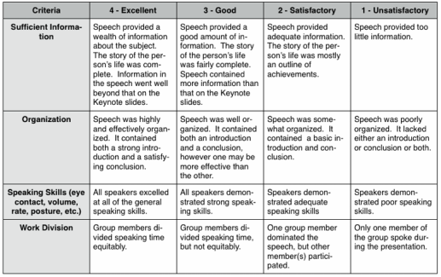
DO NOT INCLUDE THE WORK DIVISION UNLESS YOU HAD THEM INTERVIEW OTHERS AS A GROUP.

