Title: Child Labor and Local Latino Workers

Overview ⎸ Preparation ⎸ Lesson Procedure ⎸ Evaluation

Overview

Lesson Overview | This lesson looks at child labor and the lack of child labor laws especially for Mexican children by exploring images, newspaper articles and factual accounts from primary resource sets. Using student choice, students are able to show their understanding through a student choice project at the end. There is also an extension to another lesson created by a teacher in the Boulder County Latino History Project (BCLHP) who was actually a migrant child worker. Maria Ramirez- Tools That Sustain
Author(s) & School | Emily Sanger  Timberline PK-8
Grade Level/  Course | Elementary 4th/5th grade
Standards | WIDA CAN Do Descriptors Key Used Edition  Grade 4-5  SPEAKING  English Language Proficiency Level (ELP) 1: Students can explain by • Naming components of phenomena using illustrations, photographs  English Language Proficiency Level (ELP) 2: Students can explain by • Giving reasons why or how something works using diagrams or images  English Language Proficiency Level (ELP) 3: Students can explain by • Comparing data or information  English Language Proficiency Level (ELP) 4: Students can explain by • Presenting detailed information in small groups  LISTENING  ELP Level 1: Students can process recounts by • Matching oral words and phrases to content-related pictures or objects • Identifying the topic in oral statements  ELP Level 2: Students can process recounts by • Classifying time related language in oral statements (e.g., present, past, future) • Connecting the context of narratives (e.g., the who, what, when, & where) to illustrations  ELP Level 4: Students can process recounts by • Sequencing events or steps based on oral reading of informational text • Recognizing the language of related genres (e.g., news reports, historical accounts)  ELP Level 5: Students can process recounts by • Identifying related information from multiple sources presented orally  ELP Level 6: Students can process recounts by • Identifying the overall structure (e.g., chronology) of events, ideas, concepts, or information in oral presentations • Differentiating similarities and differences of information presented through multimedia and written text  READING  ELP Level 1: Students can process arguments by • Identifying key words and phrases of claims • Identifying a claim or an opinion in multimedia with a partner  ELP Level 2: Students can process arguments by • Identifying language indicative of points of view • Organizing evidence based on sequential language in texts • Differentiating between claims and evidence  ELP Level 3: Students can process arguments by • Identifying evidence from multiple places within text • Identifying different perspectives, stances, or points of view  ELP Level 4: Students can process arguments by • Comparing multiple points of view on a topic  ELP Level 5: Students can process arguments by • Connecting personal experience with textual evidence to strengthen an interpretation of the text • Evaluating the strength of evidence as support for claims  ELP Level 6: Students can process arguments by • Evaluating claims and evidence by drawing from multiple print sources • Differentiating from the strength of different pieces of evidence as support for claims  WRITING  ELP Level 1: Students can argue by • Selecting words and phrases to represent points of view using facts from illustrated text or posters • Using key-words or phrases related to the topic  ELP Level 2: Students can argue by • Stating reasons for particular points of view • Listing pros and cons of issues  ELP Level 3: Students can argue by • Connecting reasons to opinions supported by facts and details • Making adjustments for audience and context ELP Level 4: Students can argue by • Comparing and contrasting evidence for claims • Providing reasons and evidence which support particular points ELP Level 5: Students can argue by • Evaluating positive and negative implications associated with various positions (e.g., historical events)  •Including evidence from multiple sources  ELP Level 6: Students can argue by • Organizing ideas and information logically and coherently • Integrating information from multiple sources to provide evidence for claims
Time Required | Multi-Day  Seven 45 minute periods  First day- Images and Image Discussion/Compare & Contrast  Second day-Newspaper article and Oral recount/Compare & Contrast  Third day - Fifth day (or more depending on project selection) for creating projects and/or sharing projects with the class.
Topic | Farming/agriculture/ranching; Work done by women and children; Migrant Workers
Time Period | 1900-1919; 1920s-30s; 1940s;
Tags (key words) | Child labor, migrant workers, labor laws, Albert Borrego and Elvinia ("Bea") Martinez Borrego,  Extension activity and/or research-Maria Ramirez - Tools that sustain

Preparation (Links to worksheets, primary sources and other materials):

Materials | DAY ONE: Laptop, Google Drive and projection screen, print out Child Labor Discussion Menu and cut in half to give to students, writing utensils, paper  DAY TWO: Laptop, Google Drive and projection screen, print out Newspaper article, print out Account of Albert Borrego, print out Child Labor Discussion Menu and cut in half to give to students, writing utensils, paper  DAYS THREE-SEVEN: Other ½ of Child Labor Discussion Menu-Project Topic Suggestions, Laptop, Laptops/Chromebooks for students, writing utensils and paper, markers, crayons, colored pencils, iPads.
Resources/Links | Newspaper clip to print out, "Beet Growers Warned"  Account of Albert Borrego  Child Labor Discussion Menu and Project Topic Suggestions  Maria Ramirez- Tools That Sustain Presentation  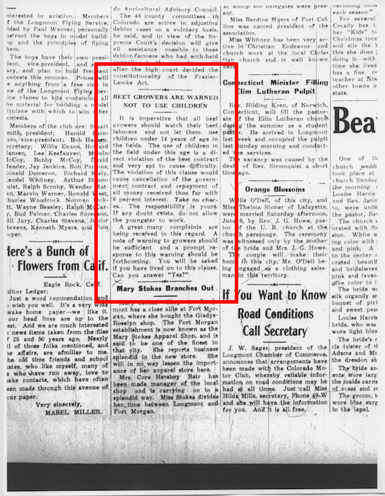

Lesson Procedure (Step by Step Instructions):

DAY ONE
Step 1: Write the questions you are asking students on the board into three sections

Observe | What do you notice first? | Find something small but interesting in the artifact | What do you notice that you didn’t expect? | What do you notice that you can’t explain?
Reflect | Where do you think this artifact came from? | Why was this artifact taken/shared? | If someone shared this today, what would be the same or different? | What can you/we learn from this artifact?
Questioning | What do you wonder about? | Who______? | Where_______? | How_____?
Step 2: (5 minutes) Give students the ½ sheet Child Labor Discussion Menu, Image Discussion Menu (see above).

Step 3: (10 minutes) Show students photo of migrant workers and have students pose questions to the group using the Discussion Menu. Students need to pick at least three different questions from the menu.

Step 4: (10 minutes) Show students image of child in walker in field and have students pose questions to the group using the Discussion Menu. Students need to pick at least three DIFFERENT questions than they asked about the previous image.

Step 5: (10 minutes) Ask students to talk about the similarities and differences between the two images, create and utilize a Venn Diagram to compare and contrast the two images.

Step 6: (10 minutes) Have students share their Venn Diagrams with another student.

DAY TWO-
Step 1: Write the questions you are asking students on the board into three sections

Observe | What do you notice first? | Find something small but interesting in the artifact | What do you notice that you didn’t expect? | What do you notice that you can’t explain?
Reflect | Where do you think this artifact came from? | Why was this artifact taken/shared? | If someone shared this today, what would be the same or different? | What can you/we learn from this artifact?
Questioning | What do you wonder about? | Who______? | Where_______? | How_____?
Step 2: (5 minutes) Have students take out the ½ sheets of Child Labor Discussion Menu, Image Discussion Menu

Step 3: (15 minutes) Hand out Newspaper article clipping and have students pose questions to the group using the Discussion Menu. Students need to pick at least three DIFFERENT questions from the menu that they had not utilized in the previous activity.

Step 4: (15 minutes) Hand out Account of Albert Borrego and have students pose questions to the group using the Discussion Menu. Students need to pick at least three DIFFERENT questions from the menu that they had not utilized in the previous activity.

Step 5: (10 minutes) Ask students to talk about the similarities and differences between all four of the artifacts. Create a Venn Diagram as a class discussing the differences/similarities between the photo artifacts and the text.

DAYS THREE-SEVEN
Step 1: (5 minutes) Hand out bottom ½ sheet of previously cut out Child Labor Discussion Menu - Project Topic Suggestions

Step 2: (10 minutes) Discuss project requirements with students. Students are allowed to choose any one (or more) of the Project Topic Suggestions from the ½ sheet. Make sure to point out that there is a choice where students can come up with their own project after discussing it with you as the teacher.

Step 3: (30 minutes) Students work on projects during class time while the teacher circulates and assists as necessary.

Extensions and Differentiation:
Students can work with partners or in a small group
Student choice on project and presentation
Students are able to use technology and/or paper pencil to complete daily activities

Evaluation/Assessment: (Methods for collecting evidence of student learning)

Possible Summative/Formative Assessments:
- Completed Venn Diagram from day one
  - Using the Venn Diagram students write a compare/contrast paragraph using evidence from the text
- Completed Student Project chosen (or discussed with teacher) and presented to a small group, class or grade level
- Daily discussion and participation observations

