Title: Health and Medicine within the Latino community: A cultural comparison (remedios y curanderismo)- A Spanish Language Lesson
Overview ⎸ Preparation ⎸ Lesson Procedure ⎸ Evaluation

Overview

Lesson Overview | In this lesson students will use the five modes of communication (reading, writing, speaking, listening and movement) in the target language (Spanish) to explore health and medicine as practiced by the latino community. Students will also have the opportunities to culturally compare and contrast their means of health and medicine through primary sources dissecting leading socio-economic issues, values and traditions that contributed to the practice of curanderismo.  Students will learn about the plants/herbs used in curanderismo/remedios, write a step by step instruction for a remedio and role play the use and purpose of the remedio in class.
Author(s) & School | Evelyn Firman, Peak to Peak Charter School
Grade Level/  Course | High School, Spanish Honors  Essential Question: Why is it important to understand cultural differences such as those found in medicine and how does it allow us to further understand the people who practice it?  Lesson extension opportunities for a complete unit: Invite a curandero/a to speak to the class. Invite a parent to share some remedies. Create stations where students can make their own remedios such as salves and oils potentially walking away with a collection of remedios used to cure a variety of ailments.  Expand on the supernatural connection
Standards | CDE Standard:1b. Communication in Languages Other Than English, a. Summarize, explain, and critique information from a variety of oral, written, and visual sources (DOK 2-4)  CDE Standard: 2a, 2b. Knowledge and Understanding of Other Cultures  a. Compare daily practices of people in the target culture(s) with their own (DOK 2-3)  a. Analyze and assess factors (education, economics, history, religion, climate, geography) that impact cultural products (DOK 2-4)  CDE Standard: 3. Connections with Other Disciplines and Information Acquisition, a. Extract information and decipher meaning, including inferences, from authentic resources (DOK 2-3)
Time Required | 3 day lesson with 1 day of presentations
Topic | Health/medicine/healing
Time Period | 1920s-30s; 1980s-90s; 2000-2013
Tags (key words) | Health, medicine, curanderismo, remedios, curandero, curandera, latino, chicano

Preparation (Links to worksheets, primary sources and other materials):

Materials | ppt, Spider Web graphic organizer, butcher paper, markers, pencils, construction paper, sticky notes, community garden or herb/plant specimen, Final project assignment and rubric.
Resources/Links | Primary Sources:  Food, Health and Medicine  https://localhistory.boulderlibrary.org/islandora/object/islandora%3A77544?solr_nav%5Bid%5D=a61bc2fbc5b76f948426&solr_nav%5Bpage%5D=0&solr_nav%5Boffset%5D=0(Audio minute 78:40 - 88) on Curanderismo  http://teachbocolatinohistory.colorado.edu/primarysource/draft-account-of-jose-hilario-j-h-cortez-and-maria-sabina-maes-cortez-p-3-2/  Other Sources:  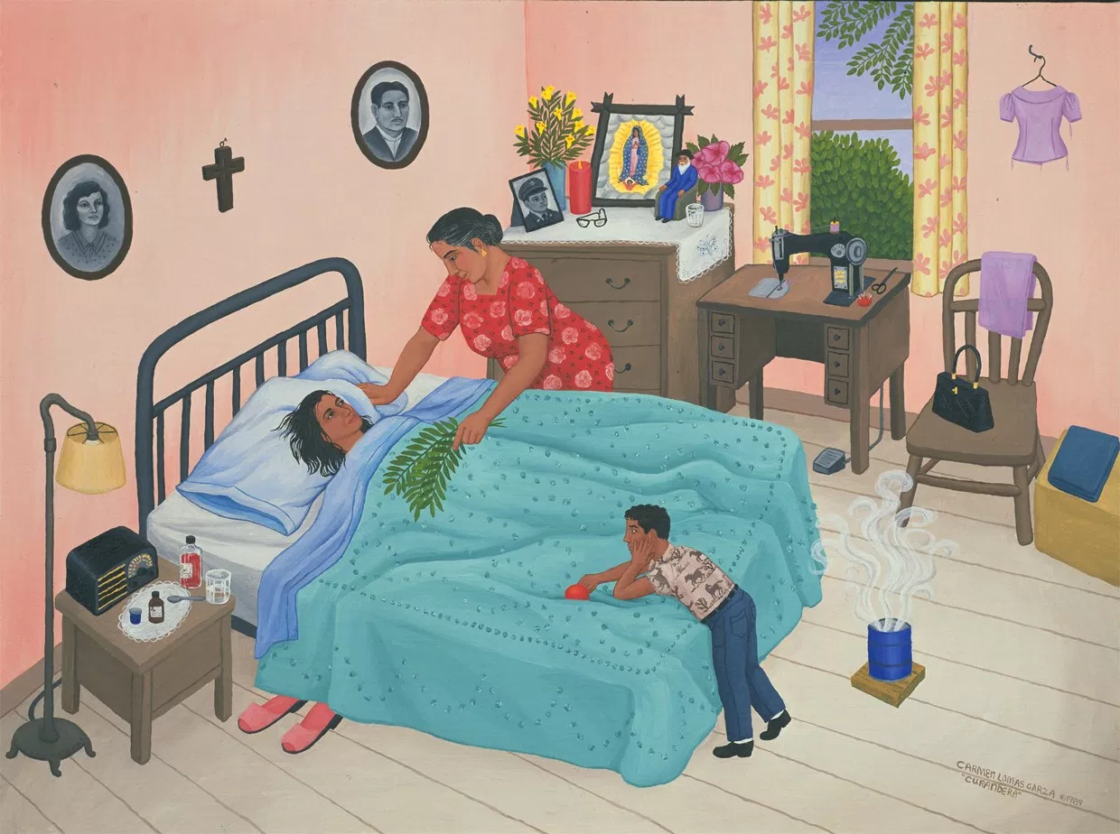  https://i0.wp.com/xicanation.com/wp-content/uploads/2014/06/curandera.jpg

Lesson Procedure (Step by Step Instructions):

Day One
Bell Ringer: Students are presented with a picture of a limpia. Students write for 5 minutes about the picture. What do you see? Describe the picture? What/Describe do you think is happening.

Shoulder partners: 1 minute, share your writing with your shoulder partner.
Students raise their hand if they wrote something similar.
2 minutes: Discuss as a class.

3 minute intro: Teacher introduces the concept of curanderismo and the important role it plays within the Latino community.

Students listen to Atenpatzin interview, the following questions are written in large letters on butcher paper around the room.

5 minutes: As a class we read the questions for comprehension. As interview plays, students write their answers on sticky notes.
Preguntas:
Según Atekpatzin, ¿Qué es el curanderismo? Escribe la definición.
¿Por qué
es que la familia de Atekpatzin practica el curanderismo?
- Escribe por lo menos 3 ejemplos.
·
En tu opinión, ¿Qué es la diferencia entre el curanderismo y la medicina tradicional en los EE.UU? ¿Cultural?etc...
·
Escribe el elemento más importante sobre el curanderismo
·
¿De dónde debe llegar la curación de la comunidad indígena?

http://oralhistory.boulderlibrary.org/interview/oh1898/
10 minutes: Audio will be paused every 3 minutes to give students time to reflect and write.
Once audio is complete, students will move about the room to place their sticky notes on individual butcher paper.

5 minutes: In silence, students walk around and read answers their peers provided. Students respond to their peers answers, agreeing or disagreeing or adding to the answers. Students initial their comments.

8 minutes: Students create a spider web graphic organizer and in their table groups use the questions provided to organize the information.

8 minutes: As a class we walk through each question and discuss answers.

3 minute Closure: In your own words, why is curanderismo important to the Latino community?

Day 2:
3 minute Bell Ringer: Curanderismo: Draw a picture and define it. Then reflect on the reasons why latino families resorted to Curanderismo. Define the word Remedio (it’s a cognate) You may use your graphic organizer and notes on butcher paper.

1 minute: pair and share, stand up and find a partner across the room, someone not in your table group.

2 minutes: define Remedios Then cold call students and reflect on the Why? Question.

6 minutes: Students work in pairs and read the following excerpt:
http://teachbocolatinohistory.colorado.edu/primarysource/draft-account-of-jose-hilario-j-h-cortez-and-maria-sabina-maes-cortez-p-3-2/

8 minutes: Students label the back side of the graphic organizer “Remedios” and write down the remedios sabina used for ailments.

2 minutes:Students then create a group of four and discuss their findings.

3 minutes: Students quickly create a 5 page booklet using of construction paper. They are to leave the booklet blank as they will use it to record plants/herbs, their healing power and any active ingredients found in the community garden.

25 minutes:as a class we take a walk to our community garden and open space where we research healing plants and herbs that grow in our very own backyard. As students discover these herbs and plants they are to draw it, label it and describe their healing powers in their booklet. Additionally, students must describe the prescription western medicine doctors would prescribe for such ailment.

Closure: Students share 1 finding orally with Senorita Firman on their way out.

Day 3:
3 minutes: Students finish working on their booklets, if done students share with shoulder partner.

3 minutes: Cold call and as a class we discuss the healing power of the herbs and plants they discovered.

6 minutes: teacher introduces project/assessment to the class located under “Evalution/Assesment”

5 minutes: Teacher breaks down the rubric used for the project

25 minutes: Students work in pairs to research an ailment, a remedio curandero and a prescription as prescribed by western medicine. Students also work on their 2 minute Skits.

2 minute Closure: Stand up and pair up with a student researching a different ailment and share their finding.

Day 4:

10 minute Bell Ringer: Students work with their partners to complete any last minute work and practice skit.

3 minutes: Teacher models the use of the graphic organizer
Every student uses a graphic organizer to highlight: Peers, ailment, remedio curandero and western medicine prescription.
http://teachbocolatinohistory.colorado.edu/wp-content/uploads/2017/12/Organizador.docx

Students present for the remainder of the class, taking a break between every 3 presenters to discuss their findings.

Closure: Pass the marker, every student individually answers the following question on the board silently: Why is it important to understand cultural differences such as those found in medicine and how does it allow us to further understand the people who practice it?

Students read their peers answers on the board as they wait writing any new ideas, “ahas” or questions on the back of the graphic organizer, they need a minimum of 2.
Students turn in completed graphic organizers at the end of class.

Evaluation/Assessment: (Methods for collecting evidence of student learning)

Tratamiento con remedio curandero vs. Medicina tradicional. (40 assessment points)
For this project students work in groups of 2. They choose an ailment and research both remedio curandero as well as prescriptions prescribed by western medicine. Students write down the remedio recipe in detail explaining the step by step instruction and how to use it as well as the medication a regular doctor might prescribe for such ailment.
Then, students must write a 2 minute script were student 1 plays the curandero/a and student 2 plays the sick person. Students will role play for the entire class making sure to talk about the ailment, the remedio suggested as well as the recipe and instructions. Students demonstrate the personal relationship between the client and curandero/a as well as the importance of such relationship during the role play.

Project: http://teachbocolatinohistory.colorado.edu/wp-content/uploads/2017/12/Tratamiento-con-remedio-curandero.pdf

Rubric: https://docs.google.com/document/d/1H3YzDHOBftl6iI9XiIh0Cqb7xs2zHHoghdX2VRxDdPI/edit

