Title: Self-Portrait: Who are we? / Quien somos?

Overview ⎸ Preparation ⎸ Lesson Procedure ⎸ Evaluation

Overview

Lesson Overview | Students will build empathy and develop cultural sensitivity and awareness for themselves and others by participating in a variety of lessons which build on these topics. Students will analyze the Power of Unity Mural and discuss posed questions with each other.  n students will create a self-portrait using construction paper to produce a mosaic effect. y. Students will analyze murals and utilize the artwork analysis worksheet. In addition, a continuation lesson is included to target math content standards.
Author(s) & School | Karla Colin, Laura DeCastro, and Delia Saenz  Escuela Bilingue Pioneer
Grade Level/  Course | K-2 Grade Level
Standards | First Grade History Standard 1. a. Identify similarities and differences between themselves and others.  2nd grade Civics Standard 2. People use multiple ways to resolve conflicts or differences. d. Demonstrate skills to resolve conflicts or differences  Teaching Tolerance Standard: Identity -Students will recognize that people's’ multiple identities interact and create unique and complex individuals.  Art Standards  Standard #1: Communication – Students recognize and use the visual arts as a form of communication.  Standard #3: Materials and Techniques – Students know and apply visual arts materials, tools, techniques, processes, and technology.  Standard #5: Analysis – Students analyze and evaluate the characteristics, merits, and meaning of works of art.
Time Required | Five - 40 minute lessons
Topic | Culture/identity issues
Time Period | 1980s-90s; 2000-2013
Tags (key words) | Family, graph, conflicts, healing, resolution, sugar beets, mining, working in the fields, music, immigration

Preparation (Links to worksheets, primary sources and other materials):

Materials | - 12x18 piece of construction paper,  - school glue (not glue sticks),  - cut out different sizes and colors of shapes, pencil,  - markers or colored pencils,  - silhouette of a person
Resources/Links | Artwork Analysis Sheet  http://teachbocolatinohistory.colorado.edu/wp-content/uploads/2017/12/ArtworkAnalysis.CO_.docx  The power of Unity  http://teachbocolatinohistory.colorado.edu/wp-content/uploads/2017/12/The-Power-of-Unity-talk-1.pdf

Lesson Procedure (Step by Step Instructions):

Step 1
- Introduce the lesson by showing the, The Power or Unity mural on the project. Discuss with students mosaic art. Give the students time to observe the mural and think about what they see.
- Introduce the Artwork Analysis sheet.
- Provide students with a copy of the Artwork Analysis Sheet.
- Through small group discussions the students discuss the questions on the sheet.
- As a whole class, the students will share out the observations and/or thoughts discussed during small group discussions

Step 2
- Each student will take with a copy of the Artwork Analysis Sheet.
- Take students on tour of our school to look at murals (If you do not have murals available at your school you may provides more murals over the projector)
- Students will be encouraged to use one word or pictures to complete the sheet.
- Students will share their thoughts,ideas and /or connections.
- Share with the students the history of the mural.
Step 3
- We review what a mosaic and look at different examples of mosaics self-portraits https://www.pinterest.com/pin/167548048608871474/

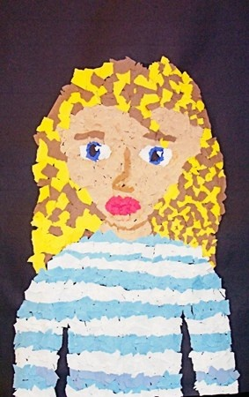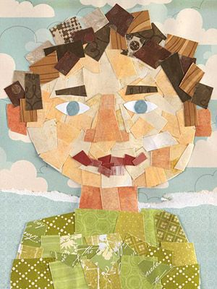
- We will talk about how we are going to create a realistic self-portrait of ourselves, using construction paper. We will discuss facial features, and how to create a realistic set of eyes, ears, noses, mouths, etc. versus a cartoonish look.

- Next the students will use hand mirrors to look at themselves and then draw an outline of their head, hair, shoulders, and shirt. Students do not need to draw in their facial details, because they need to first fill in the skin tone solid and add the facial features over that.

- Once you okay their outlines, they began filling in their portraits using the small pre-cut shapes. Then, they spread wet glue on a small area and lay the shapes down, trying to avoid empty spots. Make sure students don't spread glue over a larger area than they have time for, as the glue will dry up on them.

Step 4
- Students will share their portrait with their peers through small group discussions.
- Students will complete the Artwork Analysis sheet.
- Teacher will collect finished self portrait to use with the Math lesson that follows.

Evaluation/Assessment: (Methods for collecting evidence of student learning)

- Listening to conversations between groups
- Students’ participation in discussions and share outs
- Completions of Artwork Analysis sheet
- Completion of their mosaic self-portrait

Lesson continuation: Integrating this lesson with Math. Use the following link
http://teachbocolatinohistory.colorado.edu/wp-content/uploads/2017/12/BCLHP-Lesson-continuation-2017-Karla-C.-Laura-D.-Delia-S.docx
Lesson Extension: Students can write a short summary about themselves.

